TOPIC | QUESTION | ANSWER | ADDITIONAL RESOURCES
Signs & Symptoms | What are the signs and symptoms of COVID-19? | Reported illnesses have ranged from mild symptoms to severe illness and death for confirmed COVID-19 cases. The following symptoms may appear 2-14 days after exposure:  - Fever  - Cough  - Shortness of breath | https://www.cdc.gov/coronavirus/2019-ncov/symptoms-testing/symptoms.html
 | Should I be tested for COVID-19? | If you develop symptoms such as fever, cough, and/or difficulty breathing, and have been in close contact with a person known to have COVID-19, or have recently traveled from an area with ongoing spread of COVID-19, stay home and call your healthcare provider. Older patients and individuals who have severe underlying medical conditions or are immunocompromised should contact their healthcare prover early, even if their illness is mild. | See CDC FAQ’s on COVID-19:  https://www.cdc.gov/coronavirus/2019-ncov/faq.html
Prevention & Control | How can I protect myself and others from contacting COVID-19? | The following is a list of steps from the CDC that a person may use to protect themselves and others from getting sick:  - Clean your hands often  - Wash your hands often with soap and water for at least 20 seconds; especially after blowing your nose, coughing, sneezing, or being in a public place  - If soap and water are not readily available, use a hand sanitizer that contains at least 60% alcohol.  - Avoid touching your eyes, nose and mouth with unwashed hands  - Avoid close contact with people who are sick  - Stay home if you are sick  - Cover coughs and sneezes  - Cover your mouth and nose with a tissue when you cough or sneeze, or use the inside of your elbow  - Throw used tissues in the trash  - Immediately wash your hands with soap and water for at least 20 seconds, or use hand sanitizer if soap and water are not readily available  - Wear a facemask if you are sick  - If you are sick: You should wear a facemask when you are around others, and before entering a healthcare office  - If you are NOT sick: You do not need to wear a facemask unless you are caring for someone who is sick (and they are not able to wear a facemask). Facemasks may be in short supply and they should be saved for caregivers. | Additional information on handwashing can be found at: https://www.cdc.gov/handwashing/index.html  Videos on handwashing can be found at: https://www.cdc.gov/handwashing/videos.html  When and how to wash hands: https://www.cdc.gov/handwashing/when-how-handwashing.html
 | What are steps I can take to reduce worker exposure at my facility? | OSHA recommends the following basic steps that every employer can take to reduce the risk of worker exposure:  - Develop an Infectious Disease Preparedness and Response Plan  - Plan should address the levels of risk associated with various worksites and job tasks workers perform  - Implement Basic Infection Prevention Measures  - All employers should implement good hygiene and infection control practices  - Develop Policies and Procedures for Prompt Identification and Isolation of Sick People  - Develop Implement, and Communicate about Workplace Flexibilities and Protections  - Implement Workplace Controls  - Follow the “Hierarchy of Controls” to select the most effective ways of controlling workplace hazards  - Follow Existing OSHA Standards  - While there is no specific OSHA standard covering COVID-19, some requirements may apply (PPE, Hazard Communication, etc.) | For more information, see OSHA Guidance on Preparing Workplaces for COVID-19:  https://www.osha.gov/Publications/OSHA3990.pdf  In addition, the CDC offers Interim Guidance for Businesses and Employers  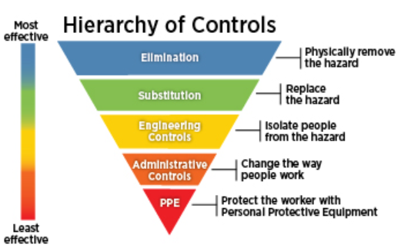
 | What strategies or actions should I take if an employee shows up to work and appears to be sick? | The CDC recommends the following strategies for employers to implement in the workplace now:  - Actively encourage sick employees to stay home  - Separate sick employees from others  - Emphasize staying home when sick, respiratory etiquette and hand hygiene by all employees  - Perform routine environmental cleaning  - Advise employees before traveling to take certain steps | Place posters that encourage proper etiquette in work areas where they are likely to be seen. Posters include:  -Staying home if you’re sick  -Coughing & Sneezing etiquette  -Hand Hygiene  More information can be found on the CDC website
Sanitation / Environmental Cleaning | What is the proper way to clean or disinfect my facility? | Routinely clean all frequently touched surfaces in the workplace, such as workstations, countertops, and doorknobs. Use the cleaning agents that are usually used in these areas and follow the directions on the label.  Provide disposable wipes so that commonly used surfaces (doorknobs, keyboards, remote controls, desks, etc.) can be wiped down by employees after each use.  For disinfection, diluted household bleach solutions, alcohol solutions with at least 70% alcohol, and most common EPA-registered household disinfectants should be effective. | CDC has listed Interim Recommendations for Cleaning & Disinfecting Households with Suspected/Confirmed COVID-19. Some recommendations may be applicable to your workplace.  See EPA’s List N: Disinfectants for Use Against COVID-19  More information regarding Disinfectants against COVID-19 can be found at EPA’s FAQ’s:  https://www.epa.gov/pesticide-registration/frequently-asked-questions-about-list-n-disinfectants-use-against-sars-cov-2
Recordkeeping Requirements | Is employee exposure to COVID-19 recordable? | COVID-19 can be a recordable illness if a worker is infected as a result of performing their work-related duties. However, employers are only responsible for recording cases of COVID-19 if ALL of the following are met:  - The case is a confirmed case of COVID-19  - The case is work-related, as defined by 29 CFR 1904.5  - The cases involves one or more of the general recording criteria set forth in 29 CFR 1904.7 (Days away from work, job restrictions or transfer, medical treatment beyond first-aid, etc.) | For more information, see OSHA’s webpage on Injury and Illness Recordkeeping and Reporting Requirements:  https://www.osha.gov/recordkeeping/
 | How do I record an employee illness related to COVID-19? | Employers should record workplace illnesses as a result of COVID-19 on the facility’s OSHA 300 Log and related forms. | A brief tutorial on completing the recordkeeping forms can be found at:  https://www.osha.gov/recordkeeping/tutorial.html
 | Do I need to report a confirmed case of COVID-19 to OSHA? | If an employee has a confirmed case of COVID-19 that is considered work-related, an employer would need to report the case to OSHA if it results in a fatality or in-patient hospitalization of one or more employees.  - Fatalities that occur within 30 days of the workplace incident involving COVID-19 are required to be reported  - In-patient hospitalization occurring within 24 hours from the workplace incident leading to the illness are required to be reported | See Reporting a Fatality or Severe Injury:  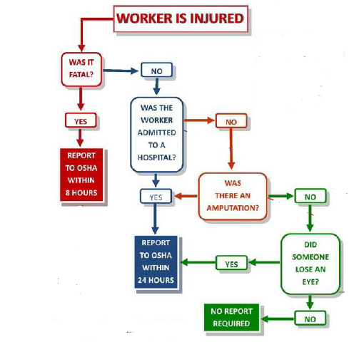  https://www.osha.gov/report.html
Personal Protective Equipment (PPE) | What type of PPE should employees wear at my workplace? | Employers are obligated to provide their workers with PPE needed to keep them safe while performing their jobs. The types of PPE required during a COVID-19 outbreak may very based on employee job duties, potential exposures, and specific Job Hazard Analyses.  Healthcare workers, Laboratory workers, First-Responders, persons conducting cleaning/disinfecting of contaminated surfaces, etc. may all be required to wear PPE. Employers should assess the hazards to which their workers may be exposed, and determine the necessary PPE to prevent exposure.  Examples of PPE include but are not limited to:  -Gloves  -Glasses/Goggles  -Face Shields/Face Masks  -Respiratory Protection- when appropriate | See specific OSHA standards regarding additional PPE requirements:  PPE- 1910.132  Eye and Face Protection- 1910.133  Hand Protection- 1910.138  Respiratory Protection- 1910.134
 | Do I need to train employees who are required to wear PPE? | Workers required to use PPE must be trained. This training includes:  - when to use PPE  - what PPE is necessary  - how to properly put on, use and take off PPE  - how to properly dispose of or disinfect, inspect for damage, and maintain PPE  - and the limitations of PPE | For more information, see OSHA’s webpage Personal Protective Equipment: https://www.osha.gov/SLTC/personalprotectiveequipment/index.html
Hazard Communication | How do I protect workers from chemical exposure? | Employers must protect their workers from exposure to hazardous chemicals used for cleaning and disinfection. Employers should be aware that common sanitizers and sterilizers could contain hazardous chemicals.  Where workers are exposed to hazardous chemicals, employers most comply with OSHA’s Hazard Communication Standard.  - Maintain copies of SDS’s for chemicals used in the workplace  - Maintain a List of Chemicals  - Ensure proper labeling of chemicals  - Properly train employees on requirements listed in paragraph (h) of the hazard communication standard | See OSHA’s 1910.1200 Hazard Communication Standard for more information:  https://www.osha.gov/laws-regs/regulations/standardnumber/1910/1910.1200  OSHA Quick Card- Safety Data Sheet  OSHA Quick Card- Labels  OSHA Quick Card- Pictogram  OSHA Steps to an Effective Hazard Communication Program
Respiratory Protection | Should I require employees to wear respirators to protect against COVID-19? | According to OSHA, workers who work within 6 feet of patients known to be, or suspected of being, infected with COVID-19, and those performing aerosol-generating procedures, need to use respirators.  Jobs to consider may include healthcare workers, laboratory workers, first responders, etc.  Workers who are sick should follow CDC guidelines and stay home when they are sick.  Refer to the signs & symptoms category of this document for CDC and OSHA guidance for all other workers who may be sick. | For more information, see OSHA Guidance on Preparing Workplaces for COVID-19:  https://www.osha.gov/Publications/OSHA3990.pdf
 | What is an N95 filtering facepiece respirator (FFR)? | According to CDC, an N95 FFR is a type of respirator which removes particles from the air that are breathed through it. These respirators filter out at least 95% of very small particles. N95 FFR’s are capable of filtering out all types of particles, including bacteria and viruses. | For more information, see CDC’s FAQ About Personal Protective Equipment:  https://www.cdc.gov/coronavirus/2019-ncov/hcp/respirator-use-faq.html#respirators
 | What requirements apply if my employees voluntarily wear N95 respirators? | According to OSHA, employees may wear respirators voluntarily if the employer determines that the respirator itself will not present:  - A hazard to the employee due to misuse  - Other hazards or conditions in the workplace  - Or a hazard to an individual employee, based on medical conditions  If the employer allows such use of a respirator, they MUST provide the user with the advisory information in Appendix D of the 1910.134 Respiratory Protection Standard. This appendix provides basic information on the proper use of respirators for employees who are voluntary users of the equipment, and thus are not required to undergo training. | For more information, see: OSHA Publication 3384- Small Entity Compliance Guide for the Respiratory Protection Standard  Appendix D to the Respiratory Protection Standard can be found here:  https://www.osha.gov/laws-regs/regulations/standardnumber/1910/1910.134AppD  In addition, see: 1910.134 Respiratory Protection Standard
 | Can employees wear other types of respirators voluntarily? | The employer must ensure that the following elements of the respiratory protection program are implemented for voluntary respirator users other than N95 respirators:  - Provisions for medical evaluation of employees  - Establishing and adhering to schedules for cleaning, disinfecting, storing, inspecting, repairing, removing from service or discarding, and otherwise maintaining respirators  Implementation of the elements of the program for a voluntary respirator user will ensure that the respirator is used properly and does not create a hazard to the user.  - A dirty respirator could cause dermatitis  - A dirty or poorly disinfected respirator could cause an unnecessary inhalation hazard  - A respirator wearer’s health could be jeopardized due to an undetected medical condition (e.g., asthma, heart condition, etc.) | For more information, see: OSHA Publication 3384- Small Entity Compliance Guide for the Respiratory Protection Standard
 | Do I need to have a written respiratory protection program if only voluntary users wear respirators at my facility? | No, if the only respirators being worn are filtering facepieces.  Yes, if other respirators, such as elastomeric APRs or powered APRs, are being used voluntarily. In this case, the written program needs to include only the elements that pertain to voluntary users; e.g., a section on medical evaluations, and one on inspection, care and maintenance.  When employees choose to voluntarily use respirators in the workplace, the employer must provide the employee with a copy of the mandatory document found in Appendix D of the respiratory protection standard. | Refer to OSHA’s 1910.134 Respiratory Protection Standard for more information on written program requirements.

